**Dead line by 19 June 2024**

**Installation process of the visual studio code**

1. **Download Visual Studio Code Installer by visit the Official Visual Studio Code Website**
2. **Open your web browser and go to the [Visual Studio Code download page](**[**https://code.visualstudio.com/**](https://code.visualstudio.com/)**).**
3. **Select the Windows Installer: by "Download for Windows" button to download the installer. Run the Installer by locating the downloaded file then initialise the installation process**
4. **Following the on screen instructions for Wizard Steps and signing the licence agreement.**
5. **Customize and configure the visual studio code software as per your preferences**
6. **Finish the installation process**
7. **Add python extension and configure Git repository**

**Installation of MySQL for Windows operating system**

1. **Download MySQL Installer by visit the Official MySQL Website: [MySQL Downloads page](**[**https://dev.mysql.com/downloads/installer/**](https://dev.mysql.com/downloads/installer/)**).**
2. **Choose "MySQL Installer for Windows" and click on Download**
3. **Find the downloaded file in your Downloads folder or the location you saved it to. Then run the installer.**
4. **Following wizard steps setup, requirements, installation and product configuration.**
5. **Before Finishing the installation set the server configurations.**
6. **Follow on screen instructions to complete the installation.**

**Python installation**

1. **Download Python Installer by opening (**[**https://www.python.org/downloads/**](https://www.python.org/downloads/)**).**
2. **Choose latest version then download.**
3. **Find the file where it was saved then run it**
4. **Following the wizard steps to customize your installation as per your preferences**

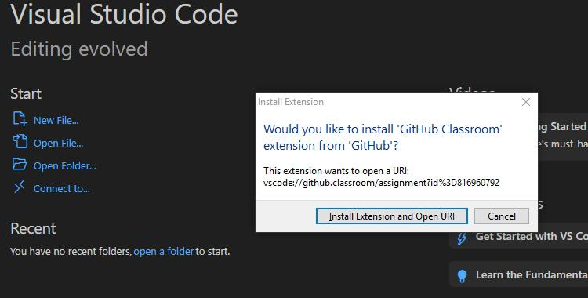

**Installation process of the IDE and GIT setup**

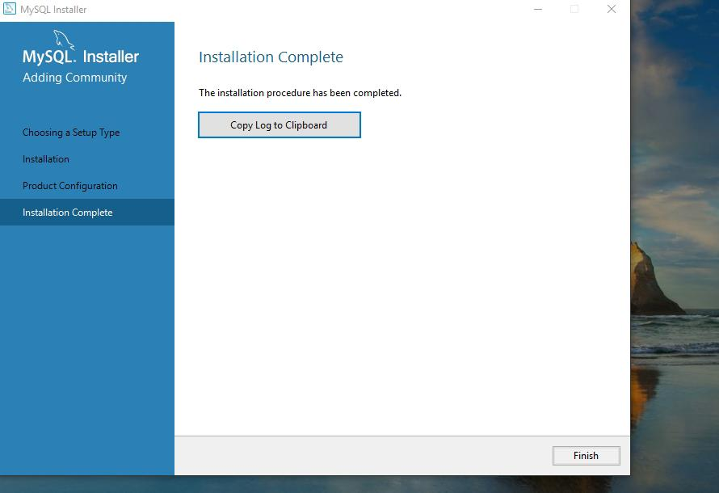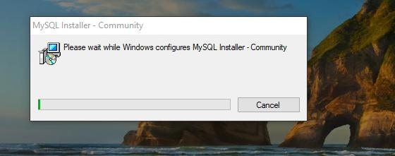

**MySQL installation process**

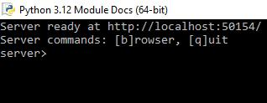

**Python software installation**

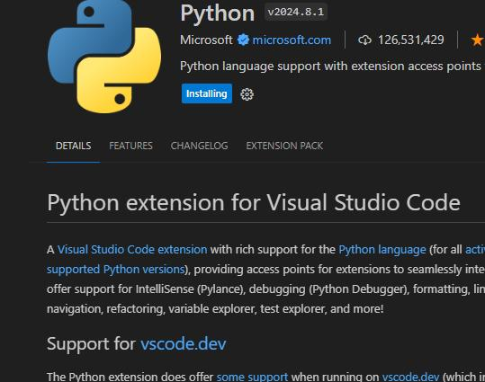**setting a python extension in the Visual studio code editor**

**Challenges I faced in this assessment**

1. My laptop suffered water damaged and have reported the issue
2. I was unable to installation windows 11 however in the coming weeks I will do it right as I am still fixing the laptop.
3. Setting the git repository was a bit confusing for me and setting Git into the visual studio code. I am not sure I did right.
4. Setting or configuring python into the visual studio code editor